ORIGINAL ARTICLE

Advanced machine learning techniques for predicting power generation and fault detection in solar

photovoltaic systems
Montaser Abdelsattar1 • Ahmed AbdelMoety1 • Ahmed Emad-Eldeen2

Received: 1 August 2024 /Accepted: 11 January 2025/Published online: 19 February 2025
◎ The Author(s) 2025

Abstract
This study investigated the application of advanced Machine Learning techniques to predict power generation and detect abnormalities in solar Photovoltaic systems. The study conducted a comprehensive assessment of various sophisticated models, including Random Trees, Random Forest, eXtreme Gradient Boosting, Linear Regression, Gradient Boosting (GB), and Categorical Boosting (CatBoost), utilizing a substantial dataset of 97,333 sets. The analysis focused on two fundamental objectives: power prediction and fault identiﬁcation, both of which are crucial for enhancing the effectiveness and dependability of PV systems. CatBoost and GB models exhibited exceptional performance in power prediction, with the maximum R-squared value of 0.994. Demonstrating a strong correlation with the data and the ability to account for a substantial amount of the variation in power generation. These models outperformed others by providing more accurate and reliable projections, which are crucial for effective solar energy management and planning. CatBoost demonstrated superior performance compared to other approaches in the ﬂaw detection test, attaining the highest performance metrics. The model achieved an accuracy of 0.999743, precision of 0.997171, recall of 0.999291, and an F1 score of 0.998230. The measures illustrated CatBoost’s exceptional ability to precisely identify problems with little errors, conﬁrming it as the most successful model among those evaluated. The exceptional precision and dependability of the Cat- Boost model in identifying faults highlighted its capacity for continuously monitoring and maintaining solar systems in real-time, consequently augmenting operational efﬁciency. The study emphasized the signiﬁcance of choosing suitable models to achieve the highest level of accuracy in predicting and detecting faults, thereby enabling the development of more sustainable and efﬁcient solar energy systems. Subsequent research should prioritize the validation of these models using varied datasets, integration of up-to-date meteorological data, and creation of defect detection methods in real-time to enhance system efﬁciency.

Keywords Fault detection . Machine learning . Photovoltaics . Power prediction . Renewable energy . Solar energy

Abbreviations ANN | Artiﬁcial neural network
AUC | Area under the curve
BA-XGBoost | Binary adaptive eXtreme gradient boosting
CatBoost | Categorical boosting
CSV | Comma-separated values
DF | Discrete Fourier transform



Neural Computing and Applications (2025) 37:8825–8844 https://doi.org/10.1007/s00521-025-11035-6

check f r
update

DL | Deep learning
DT | Decision tree
EL | Ensemble learning
ELM | Extreme learning machine
FN | False negative
FP | False positive
GA | Genetic algorithm
GB | Gradient boosting
GBM | Gradient boosting machine
GWO | Gray wolf optimization
k-NN | K-nearest neighbor
LSTM-FFNN | Long short-term memory feedforward neural network
MAE | Mean absolute error
ML | Machine learning
ML-PVPFAS | Machine learning-based PV prediction and fault analysis system
MPPT | Maximum power point tracking
MSE | Mean squared error
NRMSE | Normalized root mean square error
OCF | Open circuit faults
PV | Photovoltaic
PVPPs | Photovoltaic power plants
R2 | R-squared
RBF | Radial basis function
RES | Renewable energy sources
RF | Random forest
RMSE | Root mean squared error
RSSI | Received signal strength indicator
RT | Random trees
SDA | Similar day analysis
SVM | Support vector machine
TN | True negative
TP | True positive
XGBoost | EXtreme gradient boosting

1 Introduction

The energy crisis worldwide and climate change demand the use of Renewable Energy Sources (RES). RES, particularly solar energy, are a good choice due to their abundant availability and long-term power production capabilities. Solar energy is recognized [1, 2] as a sustainable and inexhaustible resource and is an important part of future energy strategy. Technological improvements, cost reductions, and favorable government policies help propel the global proliferation of Photovoltaic (PV) systems. All over the world, nations are investing heavily in PV technology for increasing energy security, decreasing greenhouse gas emissions, as well as transitioning to more sustainable energy systems [3, 4]. This results in the crucial need for efﬁcient methods of power generation and reliable fault detection techniques to ensure system performance and reliability as the number of PV installations signiﬁcantly increases [5, 6].

1 3 Neural Computing and Applications (2025) 37:8825–8844

Robust fault detection and diagnosis procedures are necessary to ensure the efﬁciency and reliability of PV systems. Defects in PV systems can result in substantial reductions in energy output and higher expenses for maintenance, jeopardizing the overall sustainability of solar power generation. Timely diagnosis and repair of issues is crucial for boosting the operating efﬁciency and reliability of PV installations. Advanced monitoring and fault detection systems can achieve this [7, 8]. By incorporating advanced Machine Learning (ML) methods into fault detection systems, their accuracy and effectiveness are enhanced, resulting in minimal disturbance and optimal performance of PV systems [9, 10].
Overseeing PV systems presents numerous difﬁculties, mostly stemming from the ﬂuctuating power pro- duction resulting from shifting weather patterns and technological malfunctions. The variability of solar energy, which includes factors like cloud cover, temperature variations, and shading, signiﬁcantly impacts the stability and dependability of PV systems [11, 12]. Furthermore, technical concerns such as connection problems, inverter malfunctions, and panel degradation further complicate the administration of PV systems [13].
These problems signiﬁcantly impact the total efﬁciency and maintenance expenses of PV systems. The need for advanced monitoring and control systems arises due to frequent variations in power production in order to ensure optimal performance. This not only ampliﬁes the intricacy of operations but also escalates the expenses linked to maintenance and rectiﬁcation of faults [14]. However, inadequate diagnosis or control of defects can severely waste energy, rendering the use of solar power installations economically unfeasible. Researchers today are addressing these issues by using ML and Deep Learning (DL) to identify and predict ﬂaws. These solutions improve the accuracy of power generation forecasting and anomaly detection, resulting in higher reliability and efﬁciency in PV systems [15, 16].
The integration of ML algorithms into the forecasting of power generation and identiﬁcation of anomalies in PV systems represents a signiﬁcant leap in the handling of renewable energy resources. ML models analyze the PV system performance data using advanced algorithms and large amounts of data to uncover intricate patterns. They can predict energy output very accurately and can detect potential issues with a high level of precision [9, 17]. The beneﬁts of ML for PV systems cover areas of forecasting with greater precision and detection of faults. The continuous monitoring of PV systems offered by these methods is fundamental to maximizing performance and minimizing the downtime caused by problems. A real-time monitoring system is able to notify operators about abnormalities in a blink of an eye so that they can take quick corrective measures [18]. Further, the adoption of ML brings predictive maintenance into play that most certainly cuts down operation expenditure. Through very accurate forecasting of the timing and location of defects, these systems are able to proactively plan for maintenance actions, avoiding surprise malfunctions and extending the useful life of PV components [19, 20].
The main purpose of this study is to evaluate the functionality of various advanced ML models in predicting power generation and diagnosing defects in PV systems. This research aims to ﬁnd the most suitable models that will improve the performance and dependability of PV systems, contributing to more effective and sustainable solar energy solutions. This study involves the analysis of a substantial dataset, comprising 97,333 sets of observations from a PV system. What this dataset provides is voltages, currents, power output, inverter tem- perature, daily energy generation, and system uptime. This study uses the following ML models for power prediction and fault detection, as summarized in Table 1. Results of this research will improve the understanding of the application of ML to enhance the efﬁciency and reliability of solar energy systems, leading to advancement in renewable energy technology.
The paper is structured as follows: The introduction provides background on PV systems, highlights chal- lenges, and outlines study objectives. The literature reuiew summarizes prior research on ML applications in PV systems, focusing on algorithms, ﬁndings, limitations, contributions, and novelty of the current study in advancing the ﬁeld. The methodology details the dataset, ML algorithms, and evaluation metrics used in this study. The results and discussion evaluates the performance of models in power prediction and fault detection. The limitations and future work address dataset constraints and propose improvements such as integrating weather data and real-time fault detection. The conclusion summarizes key ﬁndings and their signiﬁcance for improving PV system efﬁciency and reliability.

Table 1 ML Algorithms and their implementation for power prediction and fault detection
Task | Algorithms used | Implemented in Code
Regression (Power Prediction) | Random Forest Regressor  XGBoost Regressor  Decision Tree Regressor  Gradient Boosting Regressor CatBoost Regressor  Linear Regression | ‘‘RandomForestRegressor()’’  ‘‘XGBRegressor()’’  ‘‘DecisionTreeRegressor()’’  ‘‘GradientBoostingRegressor()’’  ‘‘CatBoostRegressor(verbose = 0∂φφ ‘‘LinearRegression()’’
Classiﬁcation (Fault Detection) | Random Forest Classiﬁer  XGBoost Classiﬁer  Decision Tree Classiﬁer  Gradient Boosting Classiﬁer CatBoost Classiﬁer  Logistic Regression | ‘‘RandomForestClassiﬁer()’’  ‘‘XGBClassiﬁer()’’  ‘‘DecisionTreeClassiﬁer()’’  ‘‘GradientBoostingClassiﬁer()’’  ‘‘CatBoostClassiﬁer(verbose = 0∂φφ ‘‘LogisticRegression()’’

2 Literature review

2.1 Previous studies

The literature review provides a comprehensive summary of prior research on the application of ML techniques in PV systems, focusing on both power prediction and fault detection. As Table 2 details, this is organized in a way that allows each study to be clear and compared to the others. The discussion of the research presents the algorithms employed in the research, the performance metrics used for evaluation, and the main ﬁndings of each study. Moreover, it presents the domains that have been explored in these studies and the associated limitations faced in these studies, to provide a context of the scope and boundaries of previous efforts in this domain. Through synthesizing this information, Table 2 provides a consolidated reference to assess the progress and challenges in the ﬁeld, and serves as a foundation to push the ﬁeld further.
A short-term PV power forecasting model was developed by Radhi et al. [21] using Artiﬁcial Neural Networks (ANNs) optimized by Genetic Algorithm (GA) and Gray Wolf Optimization (GWO) techniques. Real-time data collected on a PV prototype in Iraq under varying atmospheric conditions (sunny, cloudy, rainy) was used in the study. Metrics such as R2, Mean Absolute Errors (MAE), Root Mean Square Error (RMSE), and Mean Squared Error (MSE) were used to evaluate performance, and the ANN-GA model outperformed with R2 values greater than 0.89 in all conditions. In this model, the variations in solar irradiance were well captured and the model provided better prediction accuracy than traditional ANN and ANN-GWO methods. A limitation of the study is that it is limited to region speciﬁc data and input variables, and does not include things like humidity and dust, which would increase prediction accuracy.
Lavador-Osorio et al. [22] looked into how to use Discrete Fourier Transform (DFT) and k-Nearest Neighbor (k-NN) together to ﬁnd and pinpoint Open Circuit Faults (OCF) in PV systems. Using nighttime measurements and pulsed red light at 10 kHz, the approach achieved high predictability (90–93%) across different PV array conﬁgurations (4 9 1, 4 9 2, 5 9 1, and 5 9 2). The method is scalable for larger systems, as fault localization accuracy improves with size. While effective, its reliance on nighttime conditions and speciﬁc pulsation settings may limit broader application.
In the study of Yang and Faizan [23], a Long Short-Term Memory Feedforward Neural Network (LSTM- FFNN) model was proposed that is coupled with Decision Trees (DT), Support Vector Machine (SVM), and Linear Regression (LR) for PV fault detection. Using voltage current data under varying irradiance, the method effectively classiﬁed eight fault types with high accuracy and robustness in complex conditions. It, however, requires substantial computational resources and detailed voltage current data.

Table 2 Summary of previous studies on ML applications for power prediction and fault detection in PV systems

Referenes | Year | Power  Predication | Fault  Detection | Algorithms Used | Performance Metrics | Key Findings | Limitations
[21] | 2024 | √ |  | ANN, GA, | R2, MAE, | ANN-GA outperformed others with | Region-speciﬁc data; limited
 |  |  |  | GWO | RMSE, MSE | high accuracy (R2 > 0.89) | input variables
[22] | 2024 |  | √ | DFT with | Accuracy, | Predictability: 90% (4 × 1), 92% | Requires nighttime
 |  |  |  | k-NN | Precision, Recall | (4 × 2), 91% (5 × 1), 93% (5 × 2); scalable for larger systems | measurements; limited to speciﬁc pulsation settings
[23] | 2024 |  | √ | LSTM- | Accuracy, F1 | High accuracy and robustness in | Requires voltage-current data,
 |  |  |  | FFNN | Score | detecting multiple fault types | limited to distinct fault
 |  |  |  | with DT, |  | under varying irradiance and | characteristics, and high
 |  |  |  | SVM, and LR |  | complex conditions | computational cost
[24] | 2024 | √ | √ | SVM, RF | Accuracy, | ML models improved energy | Data irregularities due to
 |  |  |  |  | Precision, | forecasting accuracy with AUC | weather conditions
 |  |  |  |  | AUC | near 1
[25] | 2024 |  | √ | BA-  XGBoost | Accuracy,  Precision, Recall, F1 Score | BA-XGBoost achieved the highest accuracy (87.56%) | Higher computational time
[26] | 2024 | √ |  | SVM, DT, | Accuracy, | SVM (RBF) achieved 98% | Limited to one 300 MW solar
 |  |  |  | DL | Precision,  F1, AUC | accuracy, 97% precision | farm
[27] | 2023 | √ | √ | ML, EL | MAPE, | Accurate fault diagnosis and power | High computational and data
 |  |  |  |  | RMSE, | prediction for PV systems | needs
[28] | 2023 | √ |  |  | Accuracy
 |  |  |  | GBM, RF, | R2, MAE, | GBM and RF showed high | Limited to speciﬁc PV
 |  |  |  | SVM, | RMSE | accuracy and low errors, | technologies and tropical
 |  |  |  | kNN |  | suitable for real-time predictions | environments
[29] | 2020 | √ |  | SDA, GA, ELM | R2, MAE,  Normalized RMSE | SDA-GA-ELM hybrid model  achieved high accuracy, stability, and efﬁciency for day-ahead PV power prediction | Limited generalization capability due to  dependence on SDA

In photovoltaic power plants (PVPPs), Kollarov and Ostrenko [24] used classical ML methods, such as SVM and Random Forest (RF), to forecast energy generation. The study addressed the problem of weather induced data irregularities and optimized feature choices to reduce error. High performance was demonstrated by results, with Area Under the Curve (AUC) approaching 1, enabling effective energy system integration and resource man- agement. Nevertheless, the ML models were tuned carefully enough to cope with complex patterns and to make reliable predictions.
Binary Adaptive eXtreme Gradient Boosting (BA-XGBoost) was implemented by Suliman et al. [25] for the task of detecting electrical faults in PV arrays and achieved the highest accuracy (87.56%) among all methods. BA-XGBoost performed well in accuracy and fault detection reliability, but at cost of higher computational time compared to other classiﬁers.
Aldosari et al. [26] compared ML models for power prediction at a 300 MW solar farm in Saudi Arabia. The SVM with RBF performed the best among such SVMs with Radial Basis Function (RBF), polynomial, linear, and sigmoid kernels, DT, and DL models with 98% accuracy, 97% precision and AUC of 0.99 in all power classes. DL and DT models worked well, but the SVM with a sigmoid kernel was the worst. The work demonstrates that SVM with RBF is effective at ﬁnding nonlinear patterns, but only on data from one solar farm.

ML and Ensemble Learning (EL) based PV system forecasting and fault diagnosis were developed by Kar- thikeyan and Jagadeeshwaran (2023) [27] in the Machine Learning-based PV Prediction and Fault Analysis System (ML-PVPFAS). The proposed ML-PVPFAS achieved MAPE of 4.93, RMSE of 4.64, accuracy of 90.31%, precision of 93.60%, and computation time of 77.64 ms, showing its efﬁciency in PV power output prediction and complex fault identiﬁcation.
In the case of six PV technologies, power outputs were predicted by ensemble based ML models such as Gradient Boosting Machine (GBM) and RF, as evaluated by Raj et al. (2023) [28]. They used data from a 1.2 MW solar farm over three years and found GBM and RF had superior performance with low RMSE of 17.59 kW and 17.14 kW, as well as MAE of 8.28 kW and 7.88 kW respectively. Results were constrained by PV technology types and regional settings; however, these models were computationally efﬁcient, allowing for real time predictions.
In Zou et al. (2020) [29], a day ahead PV power prediction hybrid model based on Similar Day Analysis (SDA), GA and Extreme Learning Machine (ELM) was proposed. The SDA-GA-ELM model employs Pearson correlation to ﬁnd similar training days, and incorporates historical power data, meteorological factors. ELMs are optimized by GA to increase accuracy and efﬁciency. On real world data from the Desert Knowledge Australia Solar Center, the model produced high R2 , low MAE and Normalized Root Mean Square Error (NRMSE). However, it has limited generalization, as it relies on SDA.

2.2 Study highlights

As illustrated in Fig. 1, the study’s novelty lies in its dual focus on power prediction and fault detection using advanced ML, while its contributions emphasize practical insights, model recommendations, and scalability for real-world PV systems.

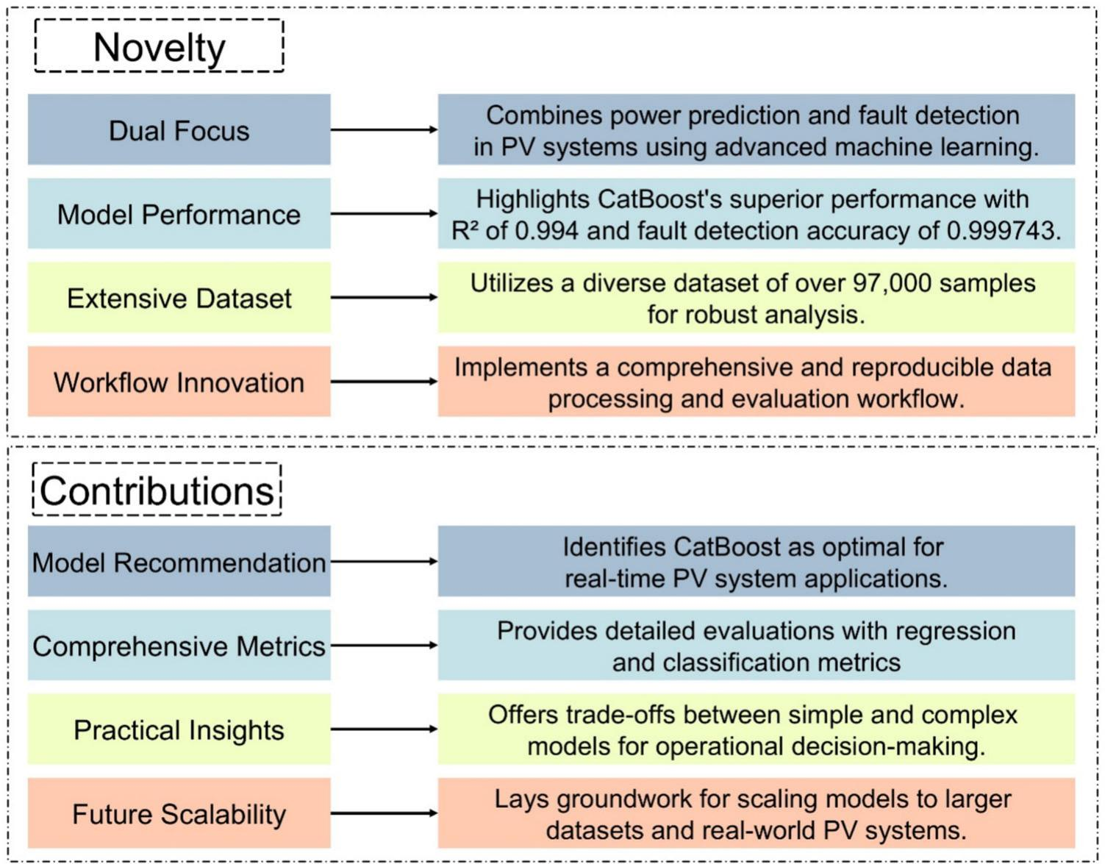
Fig. 1 Overview of key contributions and novelty of the study

3 Methodology

3.1 Data presentation

The dataset used in this investigation consists of 97,333 observations of comprehensive measurements of the efﬁciency of a PV system. This publicly available dataset [30] includes measurements such as voltages, currents, power output, inverter temperature, daily energy generation, and system uptime over a range of metrics. The subsequent illustrations offer a thorough and clear graphical depiction of these factors. Figure 2 displays the correlation matrix for the dataset’s main parameters, which include voltages (V 1 MPPT(V), V 2 MPPT(V), V 3 MPPT(V)), currents (I 1 MPPT(A), I 2 MPPT(A), I 3 MPPT(A)), Ua(V), I CA 1(A), FAC 1(Hz), power output, inverter temperature (inverter_temp), daily generation (daily_generation), uptime, and RSSI. The correlation matrix facilitates the determination of the magnitude and orientation of the associations among various variables. Figure 3 displays the distribution of power output and inverter temperature. Figure 3a displays the power output distribution, revealing a prevalence of low power values with a prolonged tail towards higher power outputs. Figure 3b depicts the distribution of inverter temperature, demonstrating a concentrated distribution around speciﬁc temperature levels. Figure 4 provides a detailed representation of the distribution of various voltage and current measurements, together with the temperature of the inverter. Each subplot exhibits the frequency

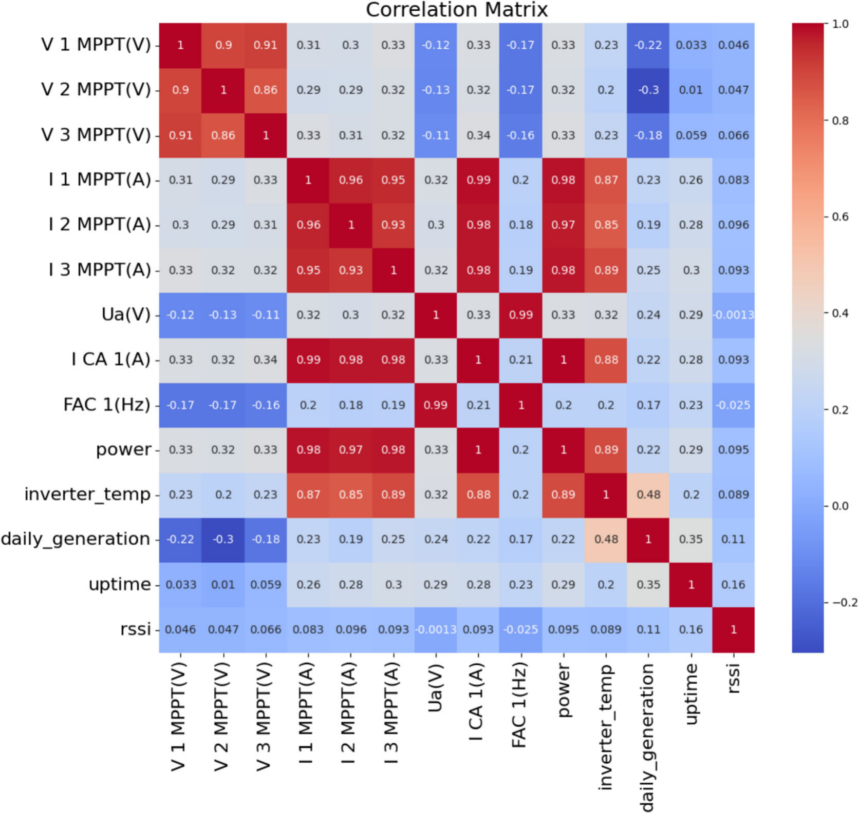
Fig. 2 Correlation matrix of key parameters in PV system performance

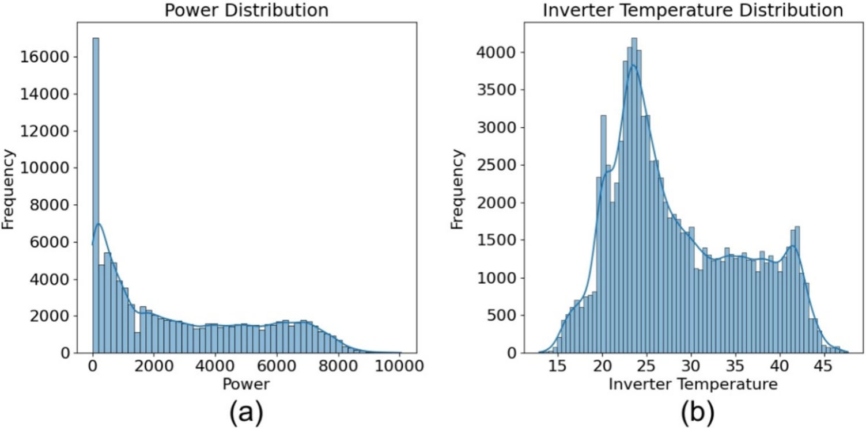
Fig. 3 Distribution of
power and inverter temper- ature a power distribution, b inverter temperature
distribution

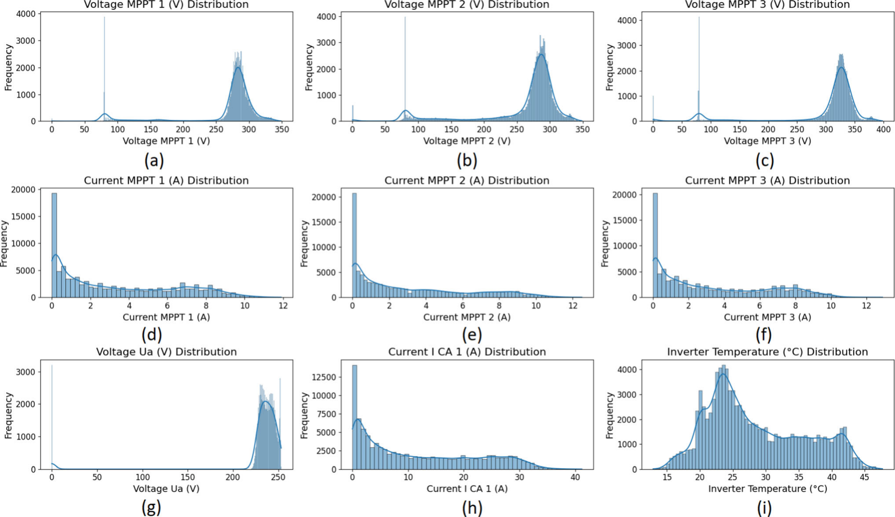

Fig. 4 Distribution of key parameters in PV system performance a voltage MPPT 1 (V), b voltage MPPT 2 (V), c voltage MPPT 3 (V), d current MPPT 1 (A), e current MPPT 2 (A), f current MPPT 3 (A), g voltage Ua (V), h current I CA 1 (A), i inverter temperature (oC)
distribution of a speciﬁc parameter, allowing for a comprehensive analysis of their behavior and variability. Figure 5 depicts the temporal changes in power output and inverter temperature. This time series Fig. 5 illustrates the variations and patterns in power generation and inverter temperature over the whole duration of the dataset. Figure 6 illustrates a scatter plot that shows the relationship between power output and inverter temperature. This is a plot of these two variables, namely, how changing inverter temperature might affect power production. The frequency of the classiﬁcations in the dataset, Wait, Normal, and Fault, are represented in a bar graph in Fig. 7. This ﬁgure provides a succinct and thorough depiction of the distribution of classiﬁcation categories throughout the dataset.

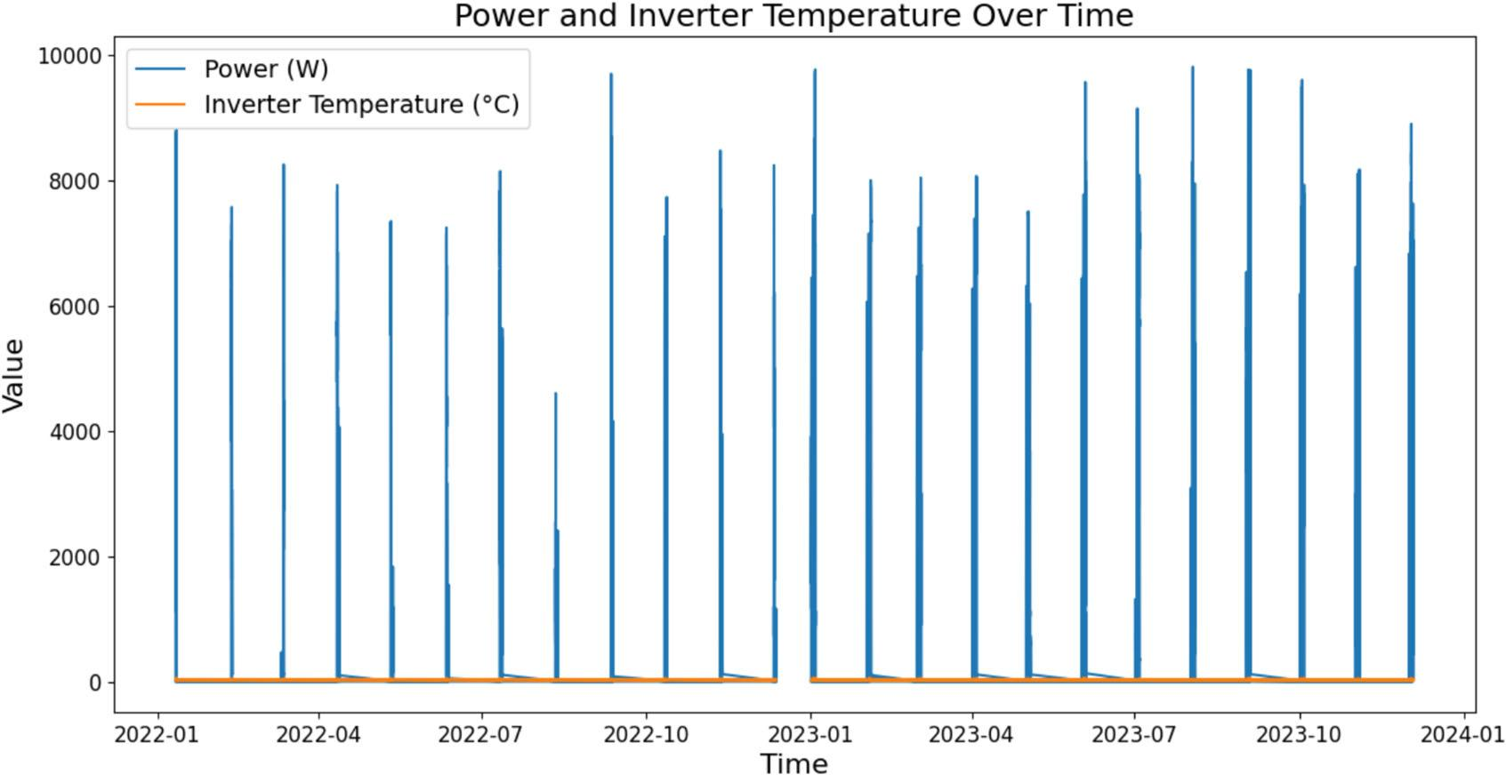
Fig. 5 Variation of power and inverter temperature over time
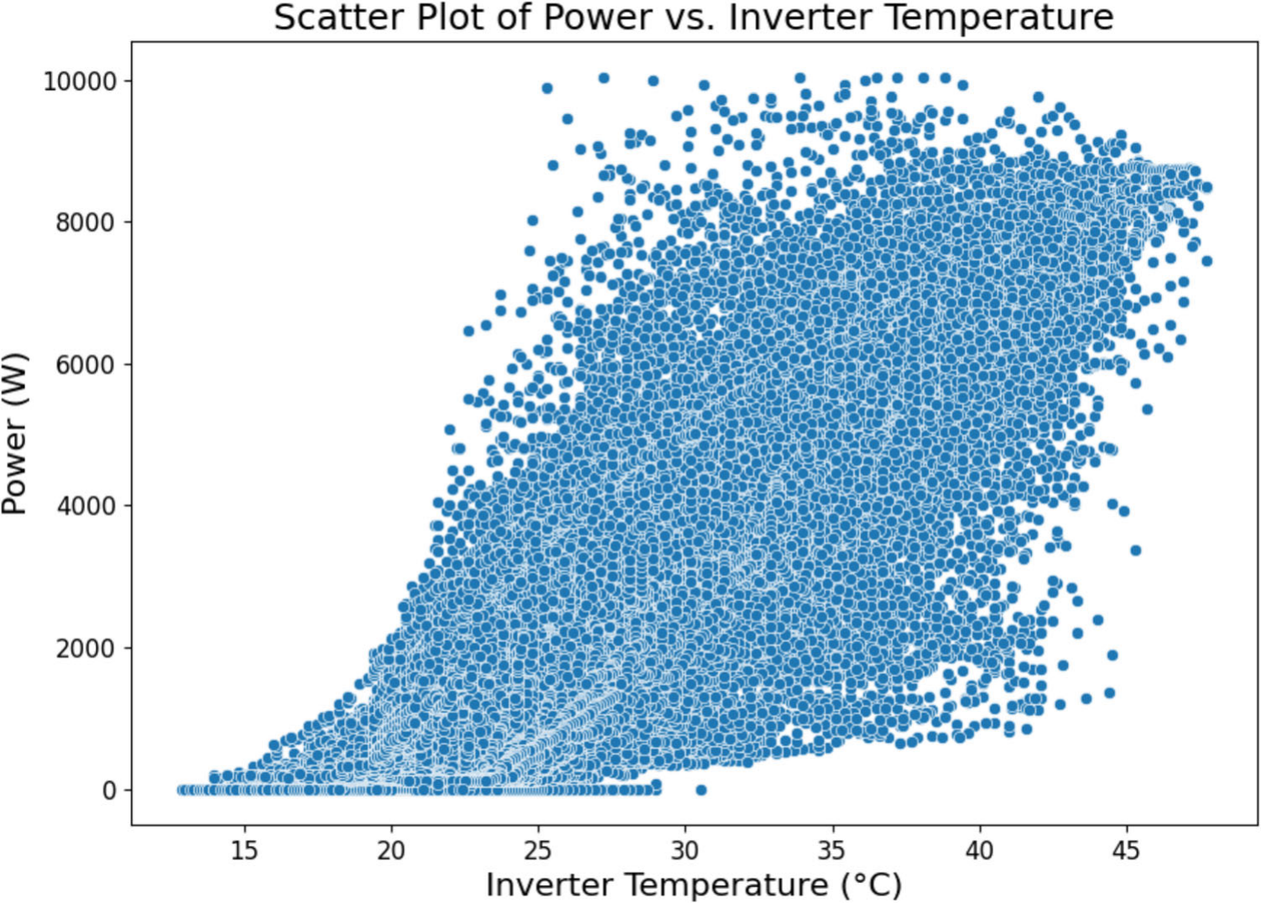
Fig. 6 Scatter plot of power vs. inverter temperature

Table 3 presents a concise overview of the essential variables in the dataset for the PV system. Table 3 presents the minimum, maximum, mean, and standard deviation values for each variable. These statistics provide a thorough summary of the dataset’s properties, allowing for the identiﬁcation of any outliers and a better understanding of the overall variability of the data.
The variables comprise voltage and current measurements acquired from the Maximum Power Point Tracking (MPPT) devices, namely Voltage MPPT 1 (V), Voltage MPPT 2 (V), and Voltage MPPT 3 (V), with mean values of 265.227 V, 258.341 V, and 296.983 V, respectively. The mean values of the current measurements, specif- ically Current MPPT 1 (A), Current MPPT 2 (A), and Current MPPT 3 (A), are 3.267 A, 3.079 A, and 3.213 A, respectively.

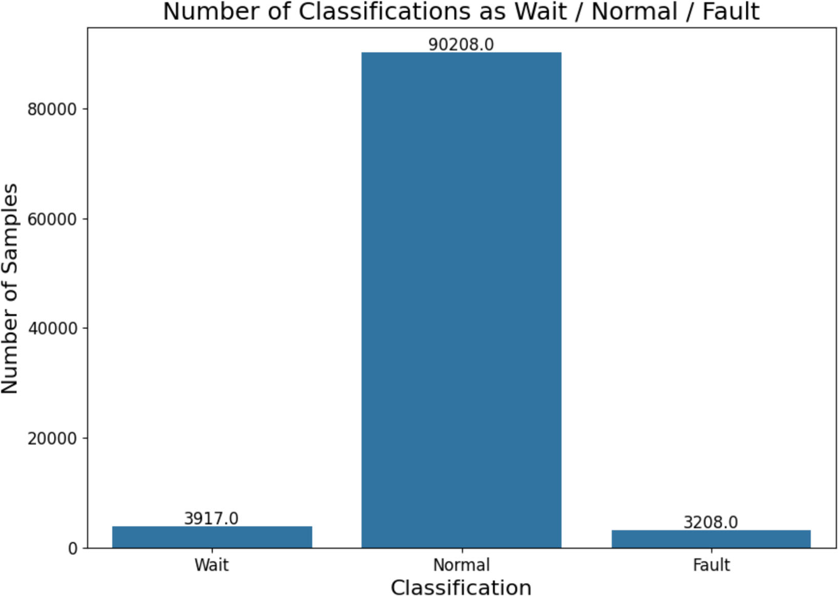
Fig. 7 Number of classiﬁcations as wait, normal, and fault

Table 3 Descriptive statis- tics of key parameters in the PV system dataset

Variable | Minimum | Maximum | Mean | Standard Deviation
Voltage MPPT 1 (V) | 0 | 348.8 | 265.227 | 60.515
Voltage MPPT 2 (V) | 0 | 348.4 | 258.341 | 67.051
Voltage MPPT 3 (V) | 0 | 398.3 | 296.983 | 80.854
Current MPPT 1 (A) | 0 | 11.9 | 3.267 | 3.044
Current MPPT 2 (A) | 0 | 12.5 | 3.079 | 3.095
Current MPPT 3 (A) | 0 | 12.9 | 3.213 | 3.086
Voltage Ua (V) | 0 | 253.2 | 230.254 | 43.130
Current I CA 1 (A) | 0 | 41.2 | 11.487 | 10.304
Frequency (Hz) | 0 | 50.42 | 48.348 | 8.923
Power (W) | 0 | 10,045 | 2784.968 | 2543.888
Inverter Temperature (oC) | 12.9 | 47.7 | 28.469 | 7.365
Daily Generation (kWh) | 0 | 58.9 | 16.368 | 15.826
Uptime (minutes) | 121 | 1660 | 858.513 | 446.198
RSSI (%) | 18 | 100 | 78.102 | 11.938

Additional signiﬁcant variables consist of the Voltage Ua (V) with an average of 230.254 V and Current I CA 1 (A) with an average of 11.487 A. The frequency (Hz) has an average value of 48.348 Hz. The power output demonstrates signiﬁcant variability, with an average of 2784.968 W and a considerable standard deviation of 2543.888 W, indicating a wide range of power levels in the dataset.
The inverter maintains an average temperature of 28.469 oC and produces an average daily output of 16.368 kWh. The system’s average uptime is 858.513 min, representing the whole duration of its operational condition. The Received Signal Strength Indicator (RSSI) has an average value of 78.102%, which represents the magnitude of the transmission signal.

3.2 Machine learning algorithms

Table 4 presents a succinct juxtaposition of the ML algorithms chosen for our research article, emphasizing their classiﬁcations, advantages, and disadvantages. The algorithms provided are Random Trees (RT), RF, eXtreme Gradient Boosting (XGBoost), Linear Regression, Gradient Boosting (GB), and Categorical Boosting (CatBoost). Each algorithm possesses distinct advantages. For example, RT is straightforward to read and efﬁcient, whereas RF exhibits superior accuracy and resilience against overﬁtting. XGBoost is renowned for its exceptional per- formance and ability to effectively handle missing values, whereas Linear Regression is highly regarded for its straightforwardness and ability to be easily interpreted. GB is especially efﬁcient when dealing with structured data and offers a high degree of accuracy. However, CatBoost is renowned for its capacity to effectively manage categorical data and its resilience. Due to their multitude of qualities, they are highly suitable candidates for our research on power generation and fault detection in solar systems. This is because they collectively provide a broad range of instruments to tackle various aspects of the problem. Therefore, the study used these method- ologies to ensure a thorough and effective analysis in our research.
This study employed a full workﬂow, which is illustrated in Fig. 8, for data processing, model training, and evaluation. The study imports the necessary libraries and loads the dataset. Afterwards, the dataset undergoes data exploration and visualization tools to get a more profound comprehension of its contents. The next phase involves data preparation for ML models. Subsequently, the process bifurcates into two distinct branches: one devoted to power prediction and the other concentrated on fault identiﬁcation. Each discipline encompasses methodologies for formulating evaluation functions, evaluating regression models, and scrutinizing classiﬁcation models. The regression models are trained and evaluated, with the results recorded in a Comma-Separated Values (CSV) ﬁle and the model’s performance illustrated graphically. The process for classifying models involves training and assessing the models, storing the classiﬁcation results in a CSV ﬁle, and graphically displaying the model’s performance. The workﬂow terminates at the ﬁnal step. The use of this method guarantees a methodical and comprehensive examination, enabling accurate power estimation and identiﬁcation of faults in PV systems. Figure 8 presents the comprehensive technique used in the research, emphasizing the sequential procedures required.

Table 4 Comparison of ML algorithms used in this study

Algorithm | Type | Strengths | Weaknesses
RT | DT | Easy to interpret, fast, handles numerical and categorical data [31] | Prone to overﬁtting, complex trees may not generalize well [31]
RF | Ensemble  (Bagging) | High accuracy, robust to overﬁtting, handles large datasets [32] | Computationally intensive, less interpretable [32]
XGBoost | Ensemble  (Boosting) | High performance, handles missing values, regularization prevents overﬁtting [33] | Complex, requires careful tuning, sensitive to noisy data [33]
Linear  Regression  GB | Regression | Simple, interpretable, fast, useful for understanding relationships [34] | Assumes linearity, sensitive to outliers, underperforms with non-linearity [34]
 | Ensemble  (Boosting) | High accuracy, works well with structured data, versatile [28] | Can over ﬁt, slower training, complex [35]
CatBoost | Ensemble  (Boosting) | High performance, handles categorical data well, robust, good with default parameters [36, 37] | Less widespread, resource-intensive, careful handling needed for large datasets [38]

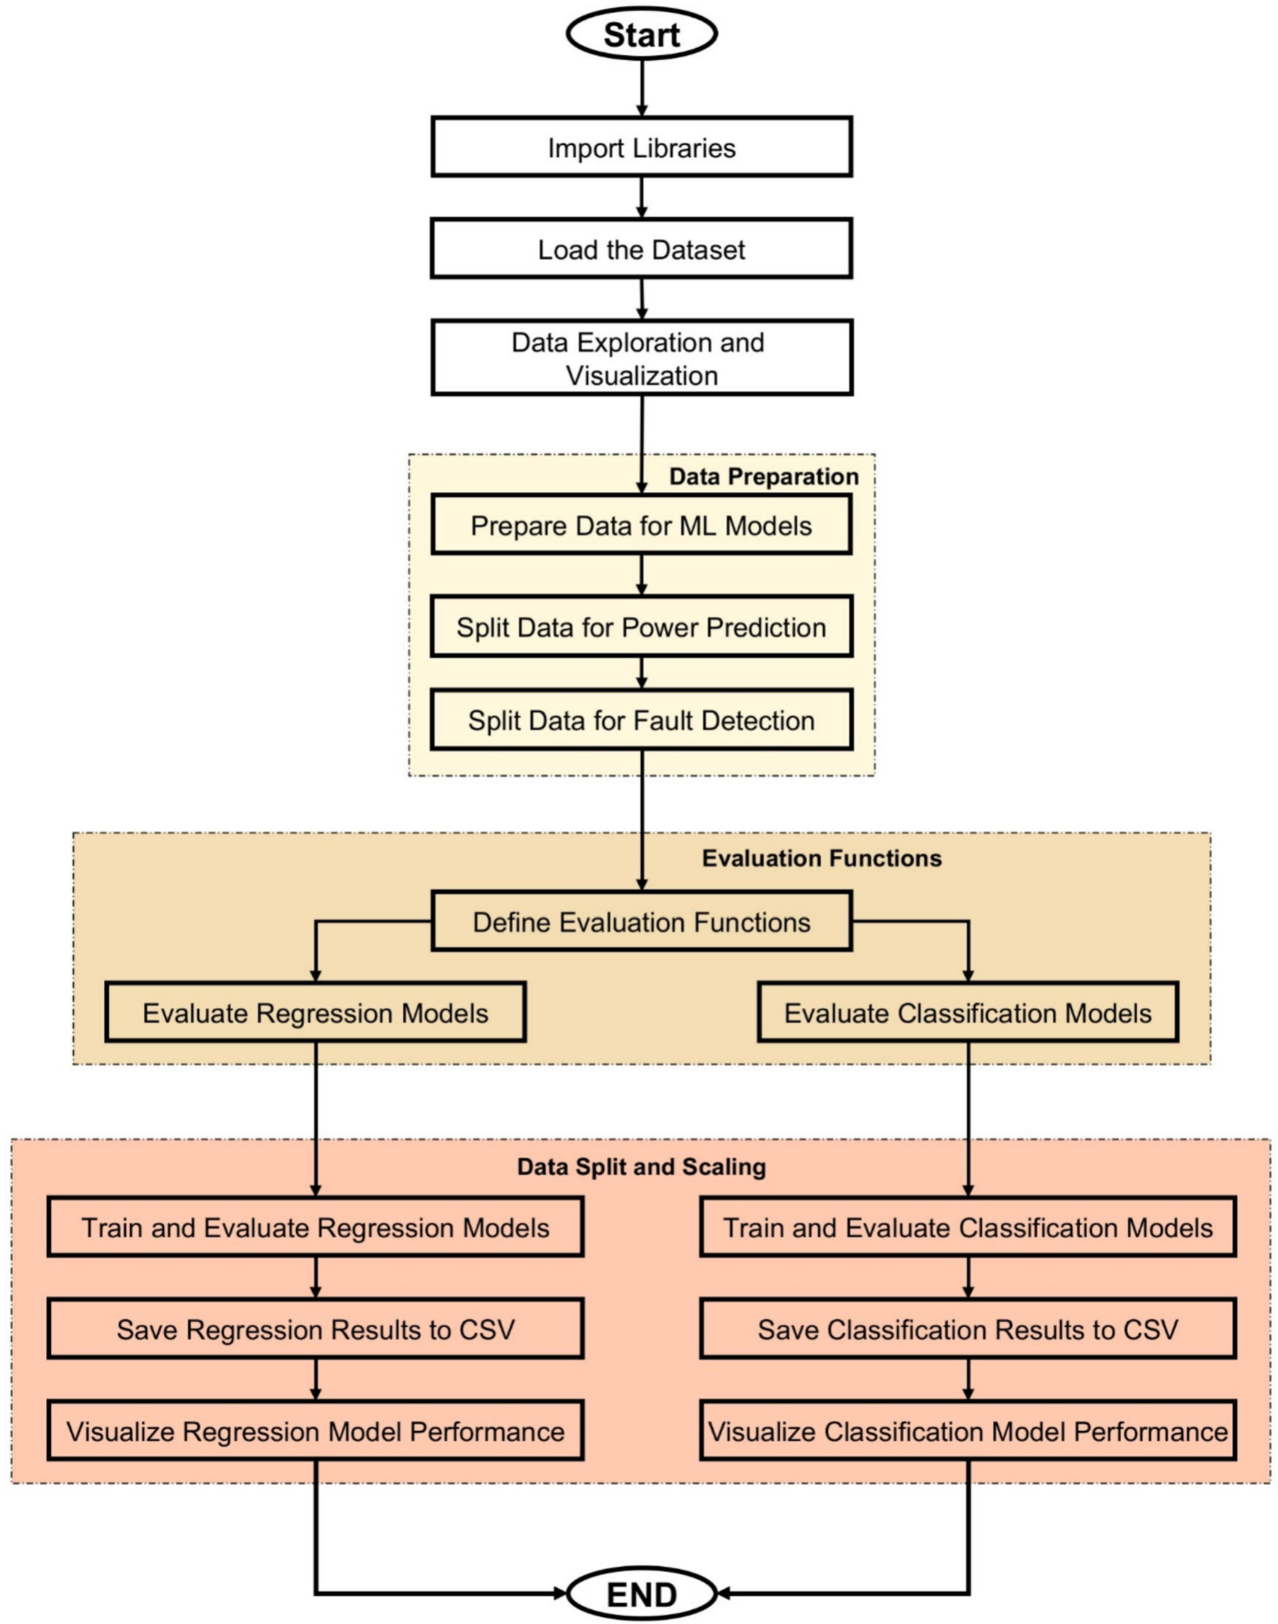
Fig. 8 Workﬂow for data processing, model training, and evaluation

3.3 Evaluation metrics

In this study, the assessment criteria have been crucial for the analysis of power prediction and defect detection tasks performed with the ML models. These metrics provide numerical basis of comparing various models and selecting the most proﬁcient option within each of activities.

The MSE [39, 40], RMSE [41], and R-squared (R2 ) metrics [42] are used in power prediction. As shown by Eq. (1), the MSE computes the average of the squared errors, or the average of the squared discrepancies between the estimated and actual values. The average amount of the errors between expected and actual values is measured mathematically by the RMSE. It is obtained by calculating the square root of MSE. The beneﬁt of RMSE is that it makes the error measure easier to comprehend by expressing it in the same units as the target variable. Equa- tion (2) illustrates this relationship. Equation (3) uses R2 to quantify how much of the variability in the dependent variable can be accounted for by the independent variables. The following are the formulae for these metrics:

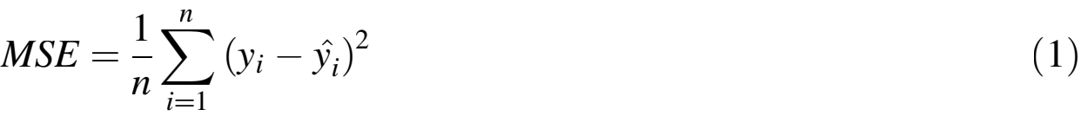

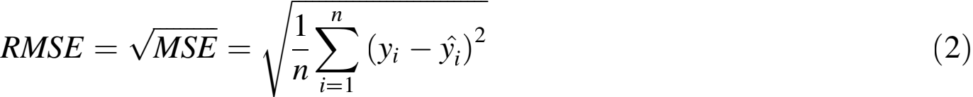

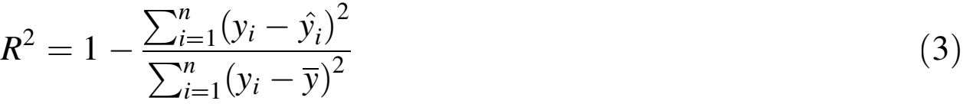

For the purpose of defect identiﬁcation, the study employ metrics such as Accuracy, Precision, Recall, and F1 Score [43, 44]. Accuracy is the proportion of accurately anticipated cases out of the total instances, as represented by Eq. (4). Precision, as deﬁned by Eq. (5), is the proportion of accurately predicted positive observations out of all the expected positive observations. Recall, also known as Sensitivity, is a measure of the proportion of properly predicted positive observations to the total number of observations in the actual class. This relationship is represented by Eq. (6). The F1 Score is calculated as the harmonic mean of Precision and Recall, which helps to strike a balance between these two measurements. This relationship is mathematically represented by Eq. (7). The formulas for these metrics are as follows:

The metrics and equations presented here offer a strong framework for assessing and comparing the perfor- mance of various ML models. This framework guarantees the selection of the most efﬁcient models for tasks involving power prediction and fault detection.

4 Results and discussion

4.1 Power generation model performance results

Table 5 presents the performance indicators of various models used in predicting power generation. These metrics are calculated from a dataset consisting of 97,333 pieces of data. Table 5 displays a progressive arrangement of the models according to their increasing efﬁciency. The given information includes the MSE, RMSE, and R2 values for each model.
The RT model demonstrates a maximum MSE of 84,000, a maximum RMSE of 289.358, and a minimum R2 value of 0.987. These ﬁndings suggest that the RT model is the least effective in calculating power in this speciﬁc situation. The RF and XGBoost models have similar performance, resulting in MSE values of around 42,000. The RF and XGBoost models have RMSE values of roughly 205.906 and 205.852, respectively. Both models achieve an R2 value of 0.993.
The models of Linear Regression, GB, and CatBoost exhibit exceptional performance. The Linear Regression model has a MSE of 41,000, a RMSE of 202.591, and a R2 of 0.994. GB demonstrates superior performance, with an MSE of 40,000, an RMSE of 200. 170, and an R2 of 0.994. The CatBoost model has superior performance compared to other models, achieving the lowest MSE of 40,000, the lowest RMSE of 198.822, and the greatest R2 value of 0.994.
The results demonstrate the efﬁcacy of GB and CatBoost models in properly forecasting power generation, with CatBoost exhibiting the highest overall performance among the assessed models. The high R2 values seen in the majority of the models indicate a robust ﬁt to the data, while the lower MSE and RMSE values reﬂect accurate predictions. This analysis emphasizes the need of selecting appropriate models to attain the utmost accuracy in forecasting power generation operations.
Based on the data shown in Table 5, the RMSE values for the models exhibit a range of roughly 200. Given that the dataset includes power values that can reach up to 10,000, an RMSE of approximately 200 indicates a rather small margin of error. To be more exact, this shows that the forecasts have an average deviation of 2% from the greatest power, which demonstrates a good level of accuracy. Given that the dataset comprises 97,333 sets, the elevated R2 values, all of which are near 1, provide additional evidence that the models effectively account for a signiﬁcant amount of the variability in the data. Hence, the RMSE values presented in Table 5 indicate that the models are effectively predicting power generation, with errors that are negligible compared to the size of the dataset.

4.2 Fault detection model performance results

The comparison of the model performance in fault detection of Table 6 is presented in terms of accuracy, precision, recall, and F1 score measure. The dataset used is a set of 97,333 sets, ensuring that models are fully evaluated.
Table 5 Model perfor-
mance metrics for power prediction

Model | MSE | RMSE | R2
RT | 84,000 | 289.358 | 0.987
RF | 42,000 | 205.906 | 0.993
XGBoost | 42,000 | 205.852 | 0.993
Linear Regression | 41,000 | 202.591 | 0.994
GB | 40,000 | 200.170 | 0.994
CatBoost | 40,000 | 198.822 | 0.994

Table 6 Model perfor- mance metrics for fault detection
Model | Accuracy | Precision | Recall | F1 Score
Logistic Regression | 0.995325 | 0.974820 | 0.960312 | 0.967512
RF | 0.999692 | 0.997169 | 0.998583 | 0.997875
XGBoost | 0.999692 | 0.997169 | 0.998583 | 0.997875
RT | 0.999692 | 0.997169 | 0.998583 | 0.997875
GB | 0.999692 | 0.997169 | 0.998583 | 0.997875
CatBoost | 0.999743 | 0.997171 | 0.999291 | 0.998230

Logistic Regression model shows slightly lower metrics than other models, with an accuracy of 0.995325, precision of 0.974820, recall of 0.960312, and an F1 score of 0.967512. Even if the metrics for Logistic Regression are lower than other models, they imply that Logistic Regression can be an appropriate choice for fault identiﬁcation, particularly in situations when a less complex model is desired.
The RF, XGBoost, RT, and GB models demonstrate equivalent performance metrics, attaining an accuracy of 0.999692, precision of 0.997169, recall of 0.998583, and an F1 score of 0.997875. These models demonstrate outstanding performance, accurately identifying mistakes with remarkably high accuracy and recall metrics.
The CatBoost model surpasses the previously described models, attaining the best accuracy of 0.999743, precision of 0.997171, recall of 0.999291, and an F1 score of 0.998230. These ﬁndings suggest that CatBoost is the optimal model for defect identiﬁcation in this dataset, since it achieves the highest level of accuracy while maintaining a satisfactory trade-off between precision and recall.
The results show that the more advanced models like CatBoost and GB are better at detecting faults in PV systems. In particular, CatBoost is the best model for this evaluation.
Figure 9 displays the confusion matrices for different models employed in fault detection within the PV system dataset. Each subplot demonstrates the efﬁcacy of a distinct model: Fig. 9a represents Logistic Regression, Fig. 9b represents RF, Fig. 9c represents XGBoost, Fig. 9d represents RT, Fig. 9e represents GB, and Fig. 9f represents CatBoost. The confusion matrices display the quantities of accurate positive, accurate negative, inaccurate positive, and inaccurate negative predictions generated by each model.
Logistic Regression matrix shows 18,021 True Negatives (TNs), 35 False Positives (FPs), 1355 genuine positives and 56 False Negatives (FNs). This is a good performance, though with a little more errors than in other models. The performance of RF, XGBoost, RT, and GB models are indistinguishable and produce 18,052 TNs, 4 FPs, 1409 True Positive (TPs), and 2 FNs. And this shows how well they are able to ﬁnd faults with so few misclassiﬁcations. Other models have lower performance than the CatBoost model which delivered 18,052 TNs, 4 FPs, 1410 real positives and just 1 FN. It demonstrates that it is very accurate in identifying ﬂaws.
The results, shown in Fig. 9, highlight the superior precision and dependability of sophisticated models such as CatBoost and GB in identifying faults. Among the models studied, CatBoost had the highest effectiveness.

5 Limitation and future work
PV technology is crucial in the global transition to sustainable energy, offering a renewable, cost-effective, and environmentally friendly solution to reducing greenhouse gas emissions and combating climate change.
The investigation has produced encouraging outcomes in both power forecasting and fault identiﬁcation. Nevertheless, there exist certain constraints that need to be resolved in future research in order to further improve the durability and practicality of the suggested approaches. A drawback is the dependence on a solitary dataset consisting of 97,333 items. Although this dataset contains a signiﬁcant quantity of data for training and evaluating models, the performance of these models may vary when applied to datasets from various solar systems or geographical regions with distinct climatic circumstances. Subsequent research should involve conducting tests on varied datasets to evaluate the models’ capacity to apply to different situations. Another constraint is the

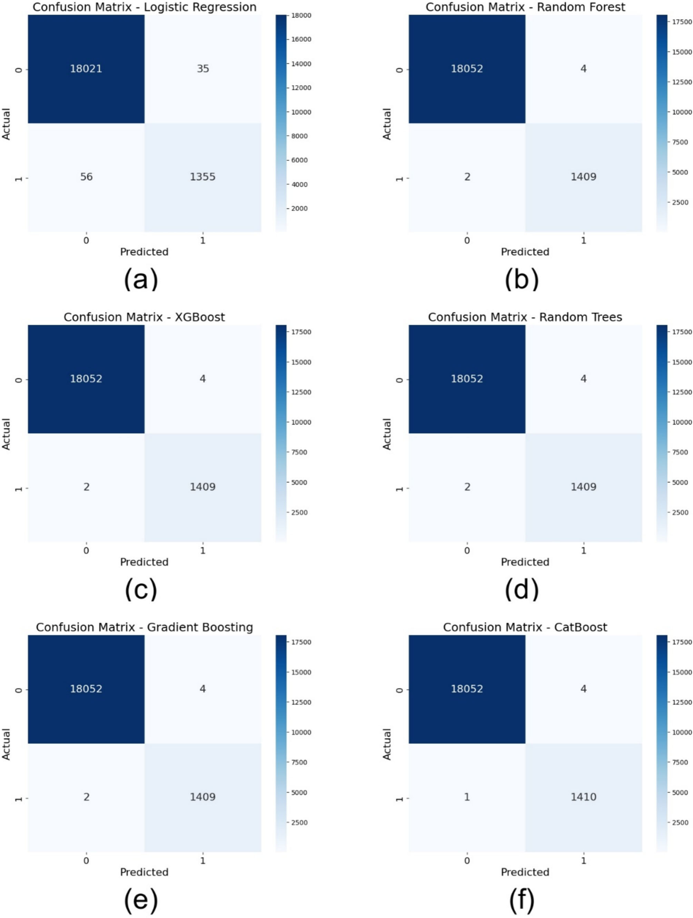
Fig. 9 Confusion matrices for fault detection models a logistic regression, b RF, c XGBoost, d RT, e GB, f CatBoost

possibility of overﬁtting observed in certain models, especially the more intricate ones such as GB and CatBoost. While these models have shown exceptional performance, there is a potential for them to underperform when applied to unfamiliar data. By implementing methods like cross-validation and regularization, this problem can be alleviated.
Regarding future work, there are multiple paths that might be followed to improve the ﬁndings of the study:
1. Incorporating weather data: By including up-to-date meteorological data, the accuracy of power output predictions could be enhanced, as solar energy production is greatly inﬂuenced by weather conditions.
2. Real了time fault detection: Creating models capable of real-time defect detection and automatic initiation of maintenance operations will greatly enhance operational efﬁciency.
3. Transfer learning: By utilizing transfer learning approaches, models can make use of pre-existing information from related domains, thereby decreasing the need for extensive training data and perhaps enhancing performance.
4. Model interpretability: Improving the comprehensibility of intricate models such as GB and CatBoost would aid stakeholders in comprehending the decision-making procedure, so bolstering trust and expediting implementation.
5. scalability: Examining the scalability of these models to bigger datasets and more extensive PV systems would guarantee their suitability in industrial-scale operations.
6. DL Integration: Incorporating deep learning techniques like CNNs and RNNs could enhance fault detection and power prediction, especially for complex patterns and larger datasets.

6 Conclusion

The results of this study represent the use of sophisticated ML methods in forecasting power generation and identifying malfunctions in solar PV systems with great accuracy. On a dataset containing 97,333 sets, this study assessed multiple models, including RT, RF, XGBoost, Linear Regression, GB, and CatBoost. The results showed that the CatBoost and GB models had outstanding performance on both fault detection and power prediction tasks. Power prediction models as well as fault detection models, according to these models, achieved impressive accuracy, precision, recall and F1 scores, and modest MSE and RMSE values respectively. These ﬁndings highlight the possibility of using ML to improve the effectiveness and dependability of solar systems, thereby contributing to the development of more environmentally friendly energy options. The high R2 values seen in the majority of the models indicate a robust alignment with the data, thereby proving the models’ capacity to elucidate a signiﬁcant proportion of the variability in power generation. This study emphasizes the signiﬁcance of choosing suitable models to achieve the highest level of accuracy in prediction and the ability to detect faults effectively. Although the results are encouraging, it is essential to evaluate these models using a wide range of datasets and in different climatic situations to assure their strength and applicability. Furthermore, by integrating up-to-the-minute weather data, creating defect detection methods that operate in real-time, and investigating transfer learning approaches, the performance of the model could be further improved. Future directions of equal importance include improving model interpretability and exploring scalability to larger datasets. In summary, this research offers a thorough assessment of sophisticated ML models, showcasing their ability to greatly enhance power generation forecasts and identify faults in solar PV systems, serving as a stepping stone for integrating more sophisticated techniques in future studies. The knowledge acquired from this study establishes the foun-

dation for future progress and breakthroughs in the sector, ultimately leading to the development of renewable
energy technology.

Author contributions All authors have equally contributed to every facet of this research. Their joint efforts encompassed: Conceptualization; Data curation; Formal analysis; Funding acquisition; Investigation; Methodology; Project administration; Resources; Software; Supervision; Validation; Visualization; Roles/Writing—original draft; and Writing—review & editing.
Funding Open access funding provided by The Science, Technology & Innovation Funding Authority (STDF) in coop- eration with The Egyptian Knowledge Bank (EKB). Open access funding provided by The Science, Technology & Inno- vation Funding Authority (STDF) in cooperation with The Egyptian Knowledge Bank (EKB). Funding provided by the Science, Technology and Innovation Funding Authority (STDF) in cooperation with the Egyptian Knowledge Bank (EKB).
Data availability Data from this study are available upon request from the corresponding author.

Declarations

Conflict of interest The authors hereby declare that there are no conflicts of interest regarding the publication of this paper. Specifically, there are no known competing financial interests or personal relationships that could have been perceived to influence the work reported herein.

Open Access This article is licensed under a Creative Commons Attribution 4.0 International License, which permits use,
sharing, adaptation, distribution and reproduction in any medium or format, as long as you give appropriate credit to the original author(s) and the source, provide a link to the Creative Commons licence, and indicate if changes were made. The images or other third party material in this article are included in the article’s Creative Commons licence, unless indicated otherwise in a credit line to the material. If material is not included in the article’s Creative Commons licence and your intended use is not permitted by statutory regulation or exceeds the permitted use, you will need to obtain permission directly from the copyright holder. To view a copy of this licence, visit http://creativecommons.org/licenses/by/4.0/.

References

1. Das D, Chakraborty I, Bohre AK, Kumar P, Agarwala R (2024) Sustainable integration of green hydrogen in renewable energy systems for residential and EV applications. Int J Energy Res 20:8258624. https://doi.org/10.1155/2024/8258624
2. Rabaia M, Abdelkareem M, Abdelkareem M, Abdelkareem M, Sayed E, Elsaid K, Chae K, Wilberforce T, Olabi A, Olabi A, Olabi A (2020) Environmental impacts of solar energy systems: a review. Sci Total Environ 754:141989. https://doi.org/10.1016/j.scitotenv.2020.141989
3. Abdelsattar M, Ismeil MA, Zayed MMAA, Abdelmoety A, Emad-Eldeen A (2024) Assessing machine learning approaches for photovoltaic energy prediction in sustainable energy systems. IEEE Access 12:107599–107615. https:// doi.org/10.1109/ACCESS.2024.3437191
4. Apeh O, Meyer E, Overen O (2022) Contributions of solar photovoltaic systems to environmental and socioeconomic aspects of national development—A review. Energies. https://doi.org/10.3390/en15165963
5. Usman Z, Tah J, Abanda H, Nche C (2020) A critical appraisal of PV-systems’ performance. Buildings. https://doi.org/ 10.3390/buildings10110192
6. Abdelsattar M, AbdelMoety A, Emad-Eldeen A (2023) A review on detection of solar PV panels failures using image processing techniques. In: 2023 24th International middle east power system conference (MEPCON), Mansoura, Egypt, pp 1–6. https://doi.org/10.1109/MEPCON58725.2023.10462371
7. Hwang M, Kim Y, Lee H, Kim Y, Cha H (2021) A study on the improvement of efﬁciency by detection solar module faults in deteriorated photovoltaic power plants. Appl Sci 11:727. https://doi.org/10.3390/APP11020727
8. Chine W, Mellit A, Pavan A, Kalogirou S (2014) Fault detection method for grid-connected photovoltaic plants. Renew Energy 66:99–110. https://doi.org/10.1016/J.RENENE.2013.11.073
9. Boubaker S, Kamel S, Ghazouani N, Mellit A (2023) Assessment of machine and deep learning approaches for fault diagnosis in photovoltaic systems using infrared thermography. Remote Sens 15:1686. https://doi.org/10.3390/ rs15061686
10. Chine W, Mellit A, Lughi V, Malek A, Sulligoi G, Pavan AM (2016) A novel fault diagnosis technique for photovoltaic systems based on artiﬁcial neural networks. Renew Energy 90:501–512. https://doi.org/10.1016/J.RENENE.2016.01. 036
11. Zhang Y, Qin C, Srivastava A, Jin C, Sharma R (2020) data-driven day-ahead PV estimation using autoencoder-LSTM and persistence model. IEEE Trans Ind Appl 56:7185–7192. https://doi.org/10.1109/TIA.2020.3025742
12. Boubakr G, Gu F, Farhan L, Ball A (2022) Enhancing virtual real-time monitoring of photovoltaic power systems based on the internet of things. Electronics. https://doi.org/10.3390/electronics11152469

13. Shin J, Kim J (2020) On-line diagnosis and fault state classiﬁcation method of photovoltaic plant. Energies. https://doi. org/10.3390/en13174584
14. Zgraggen J, Guo Y, Notaristefano A, Huber L (2022) Physics informed deep learning for tracker fault detection in photovoltaic power plants. Ann Conf PHM Soc. https://doi.org/10.36001/phmconf.2022.v14i1.3235
15. Lodhi E, Wang F, Xiong G, Zhu L, Tamir T, Rehman W, Khan M (2023) A novel deep stack-based ensemble learning approach for fault detection and classiﬁcation in photovoltaic arrays. Remote Sens 15:1277. https://doi.org/10.3390/ rs15051277
16. Kurukuru V, Blaabjerg F, Khan M, Haque A (2020) A novel fault classiﬁcation approach for photovoltaic systems. Energies. https://doi.org/10.3390/en13020308
17. Ibrahim M, Alsheikh A, Awaysheh F, Alshehri M (2021) Machine learning schemes for anomaly detection in solar power plants. Energies. https://doi.org/10.20944/preprints202112.0481.v1
18. Rodrigues S, Mu… tter G, Ramos H, Dias F (2020) Machine learning photovoltaic string analyzer. Entropy 22:205. https:// doi.org/10.3390/e22020205
19. Attouri K, Hajji M, Mansouri M, Harkat M, Kouadri A, Nounou H, Nounou M (2020) Fault detection in photovoltaic systems using machine learning technique. In: 2020 17th International multi-conference on systems, signals & devices (SSD), pp 207–212. https://doi.org/10.1109/SSD49366.2020.9364094
20. Aziz F, Haq A, Ahmad S, Mahmoud Y, Jalal M, Ali U (2020) A novel convolutional neural network-based approach for fault classiﬁcation in photovoltaic arrays. IEEE Access 8:41889–41904. https://doi.org/10.1109/ACCESS.2020. 2977116
21. Radhi S, Al-Majidi S, Abbod M, Al-Raweshidy H (2024) Machine learning approaches for short-term photovoltaic power forecasting. Energies. https://doi.org/10.3390/en17174301
22. Lavador-Osorio M, 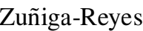 M, Alvarez-Alvarado J, Sevilla-Camacho P,  M, Rodrıguez-
Resndız J (2024) An Enhanced frequency analysis and machine learning based approach for open circuit failures in PV
systems. IEEE Access 12:96342–96357. https://doi.org/10.1109/ACCESS.2024.3425486
23. Yang N-C, Faizan M (2024) Long short-term memory-based feedforward neural network algorithm for photovoltaic fault detection under irradiance conditions. IEEE Trans Instrum Meas 73:1–11. https://doi.org/10.1109/TIM.2024. 3413159
24. Oleksandr K, Dmytro O (2024) Application of classical machine learning methods for forecasting energy generation volumes using photovoltaic power plants. J Electr Power Eng. https://doi.org/10.31474/2074-2630-2024-1-72-79
25. Suliman F, Anayi F, Packianather M (2024) Electrical faults analysis and detection in photovoltaic arrays based on machine learning classiﬁers. Sustainability 16(3):1102. https://doi.org/10.3390/su16031102
26. Aldosari O, Batiyah S, Elbashir M, Alhosaini W, Nallaiyagounder K (2024) Performance evaluation of multiple machine learning models in predicting power generation for a grid-connected 300 MW solar farm. Energies. https://doi. org/10.3390/en17020525
27. Karthikeyan G, Jagadeeshwaran A (2023) Enhancing solar energy generation: a comprehensive machine learning-based PV prediction and fault analysis system for real-time tracking and forecasting. Electric Power Compon Syst 52:1497–1512. https://doi.org/10.1080/15325008.2023.2293947
28. Raj V, Dotse S, Sathyajith M, Petra M, Yassin H (2023) Ensemble machine learning for predicting the power output from different solar photovoltaic systems. Energies. https://doi.org/10.3390/en16020671
29. Zhou Y, Zhou N, Gong L, Jiang M (2020) Prediction of photovoltaic power output based on similar day analysis, genetic algorithm and extreme learning machine. Energy. https://doi.org/10.1016/j.energy.2020.117894
30. Pablo.fuku (2022) Photovoltaic data: household generation data every 1 minute (10 kw/h). Kaggle. Open Database License (ODbL). Retrieved from https://www.kaggle.com/datasets/pablofuku/photovoltaic
31. Ahmad M, Reynolds J, Rezgui Y (2018) Predictive modelling for solar thermal energy systems: a comparison of support vector regression, random forest, extra trees and regression trees. J Clean Prod. https://doi.org/10.1016/J.JCLEPRO. 2018.08.207
32. Pahwa K, Sharma M, Saggu M, Mandpura A (2020) Performance evaluation of machine learning techniques for fault detection and classiﬁcation in PV array systems. In: 2020 7th International conference on signal processing and integrated networks (SPIN), pp 791–796. https://doi.org/10.1109/SPIN48934.2020.9071223
33. Abdurrahman G, Oktavianto H, Sintawati M (2022) Optimasi algoritma XGBoost classiﬁer menggunakan hyperpa- rameter gridesearch dan random search pada Klasiﬁkasi penyakit diabetes. Inf: Inform J 7(3):193–198. https://doi.org/ 10.19184/isj.v7i3.35441
34. Xu Z, Yang G, Geng H (2019) Power forecasting of photovoltaic generation based on multiple linear regression method with real-time correction term. In: 2019 22nd International conference on electrical machines and systems (ICEMS), pp 1–4. https://doi.org/10.1109/ICEMS.2019.8922096
35. Saigustia C, Pijarski P (2023) Time series analysis and forecasting of solar generation in Spain using eXtreme gradient boosting: a machine learning approach. Energies. https://doi.org/10.3390/en16227618
36. Sun K, Xiao X, Wu S, Chen L (2023) Fault diagnosis and state evaluation of distributed photovoltaic systems in microgrids. In: 2023 11th International conference on power electronics and ECCE Asia (ICPE 2023—ECCE Asia), pp 440–445. https://doi.org/10.23919/ICPE2023-ECCEAsia54778.2023.10213461

37. Mellit A, Zayane C, Boubaker S, Kamel S (2023) A sustainable fault diagnosis approach for photovoltaic systems based on stacking-based ensemble learning methods. Mathematics. https://doi.org/10.3390/math11040936
38. Solano E, Dehghanian P, Affonso C (2022) Solar radiation forecasting using machine learning and ensemble feature selection. Energies. https://doi.org/10.3390/en15197049
39. Treboux J, Genoud D (2018) Improved machine learning methodology for high precision agriculture. Glob Internet Things Summit (GIoTS) 2018:1–6. https://doi.org/10.1109/GIOTS.2018.8534558
40. Hodson T (2022) Root-mean-square error (RMSE) or mean absolute error (MAE): when to use them or not. Geosci Model Dev. https://doi.org/10.5194/gmd-15-5481-2022
41. Ho W, Tang B, Wong S (2021) Predicting property prices with machine learning algorithms. J Prop Res 38:48–70. https://doi.org/10.1080/09599916.2020.1832558
42. Chicco D, Warrens M, Jurman G (2021) The coefﬁcient of determination R-squared is more informative than SMAPE, MAE, MAPE, MSE and RMSE in regression analysis evaluation. PeerJ Comput Sci 7:e623. https://doi.org/10.7717/ peerj-cs.623
43. Melamed I, Green R, Turian J (2003) Precision and recall of machine translation. In: Companion volume of the proceedings of HLT-NAACL 2003-short papers, pp 61–63. https://doi.org/10.3115/1073483.1073504
44. Zheng S, Vishnu A, Ding C (2016) Accelerating deep learning with shrinkage and recall. In: 2016 IEEE 22nd International conference on parallel and distributed systems (ICPADS), pp 963–970. https://doi.org/10.1109/ICPADS. 2016.0129
Publisher’s Note Springer Nature remains neutral with regard to jurisdictional claims in published maps and institutional afﬁliations.

Authors and Afﬁliations
Montaser Abdelsattar1  • Ahmed AbdelMoety1 • Ahmed Emad-Eldeen2

☒ Montaser Abdelsattar
Montaser.A.Elsattar@eng.svu.edu.eg

1 Electrical Engineering Department, Faculty of Engineering, South Valley University, Qena 83523, Egypt
2 Renewable Energy Science and Engineering Department, Faculty of Postgraduate Studies for Advanced Sciences (PSAS), Beni-Suef University, Beni-Suef 62511, Egypt

